**Name : Veera Venkata Satyanarayana Boppana**

**ID : 700740862**

* **Question 1:**

Given list of ages = [19, 22, 19, 24, 20, 25, 26, 24, 25, 24]

* **Sort the list and find the min and max age? Add the min age and the max age again to the list? Find the median age? Find the average age?** **Find the range of the ages?**

To sort the given list of ages I used **sort()** function which sorts in ascending order and sorted the array. And used **max()** and **min()** functions to find the max age and minimum age in the list. As list is sorted now to add the maximum value I used **append()** function which adds at the end of the list and to add minimum values I used **insert()** function as it takes the index so that we can insert the value at the specified position.

To find the median age

1) if the given list is even then I used **ages[(int(agesLen/2))-1]+ages[int(agesLen/2)])/2)**

2) if the given list is odd then I used **(ages[int(agesLen/2)]))**

Next to find the average age (mean) I used sum of all the ages divided by the count of ages(or length of age list). And range is **max(ages)-min(ages)**.

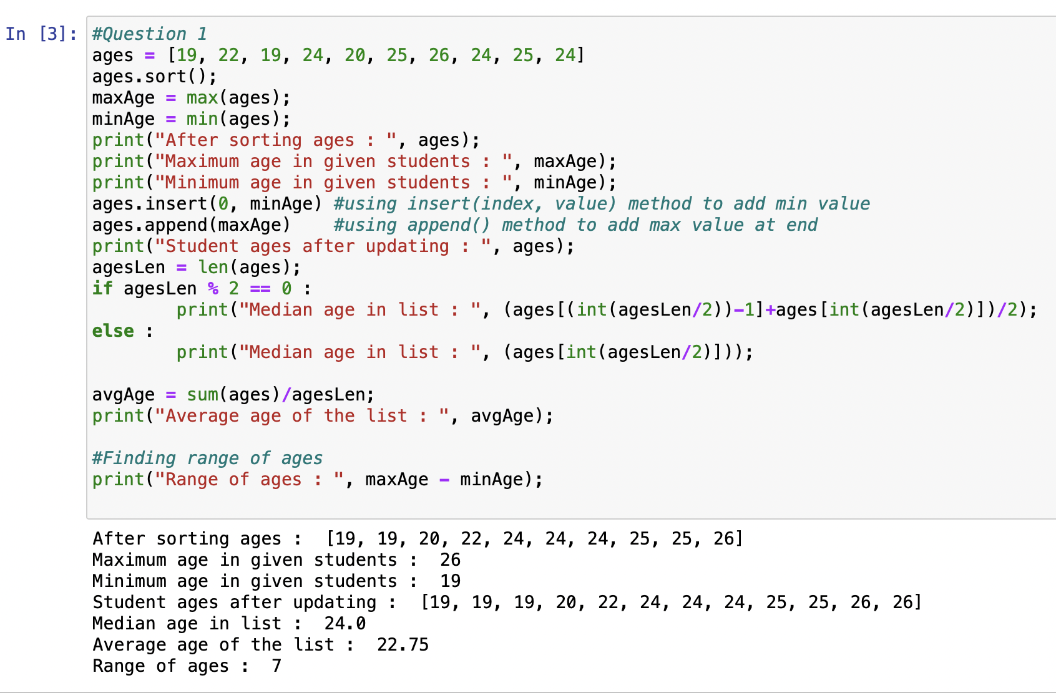

* **Question 2: Create an empty dictionary called dog? Add name, color, breed, legs, age to the dog dictionary? Create a student dictionary and add first_name, last_name, gender, age, marital status, skills, country, city and address as keys for the dictionary? Get the length of the student dictionary? Get the value of skills and check the data type, it should be a list? Modify the skills values by adding one or two skills? Get the dictionary keys as a list? Get the dictionary values as a list?**

To create an empty dictionary I used **dict**() method which will create an empty dog dictionary. **Update()** method is used to add the key-value pair to the created empty dictionary. And created a student dictionary and added key values using update(). To get the length of the student dictionary I used **len()** method**.** To access the particular value of a dictionary I just passed the respected key in the **studentD[“skills”]** and to get the data type I used **type()** function. To add some skills I used **extend()** method and used **keys()** and **values()** functions to get keys and values as lists.

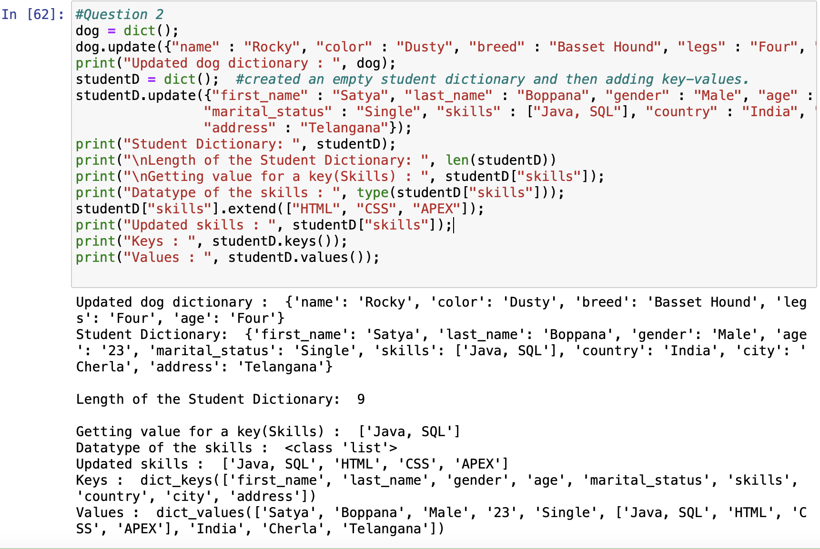

* **Question 3: Create a tuple containing names of your sisters and your brothers? Join brothers and sisters tuples and assign it to siblings? How many siblings do you have? Modify the siblings tuple and add the name of your father and mother and assign it to family members?**

Created a sisters tuple using sisters = (“Sravanthi”, “Sowmya”) and in the same way brothers tuple. Then I used ‘+’ operator to add both the tuples to siblings. And also used ‘+’ operator to add family_members.

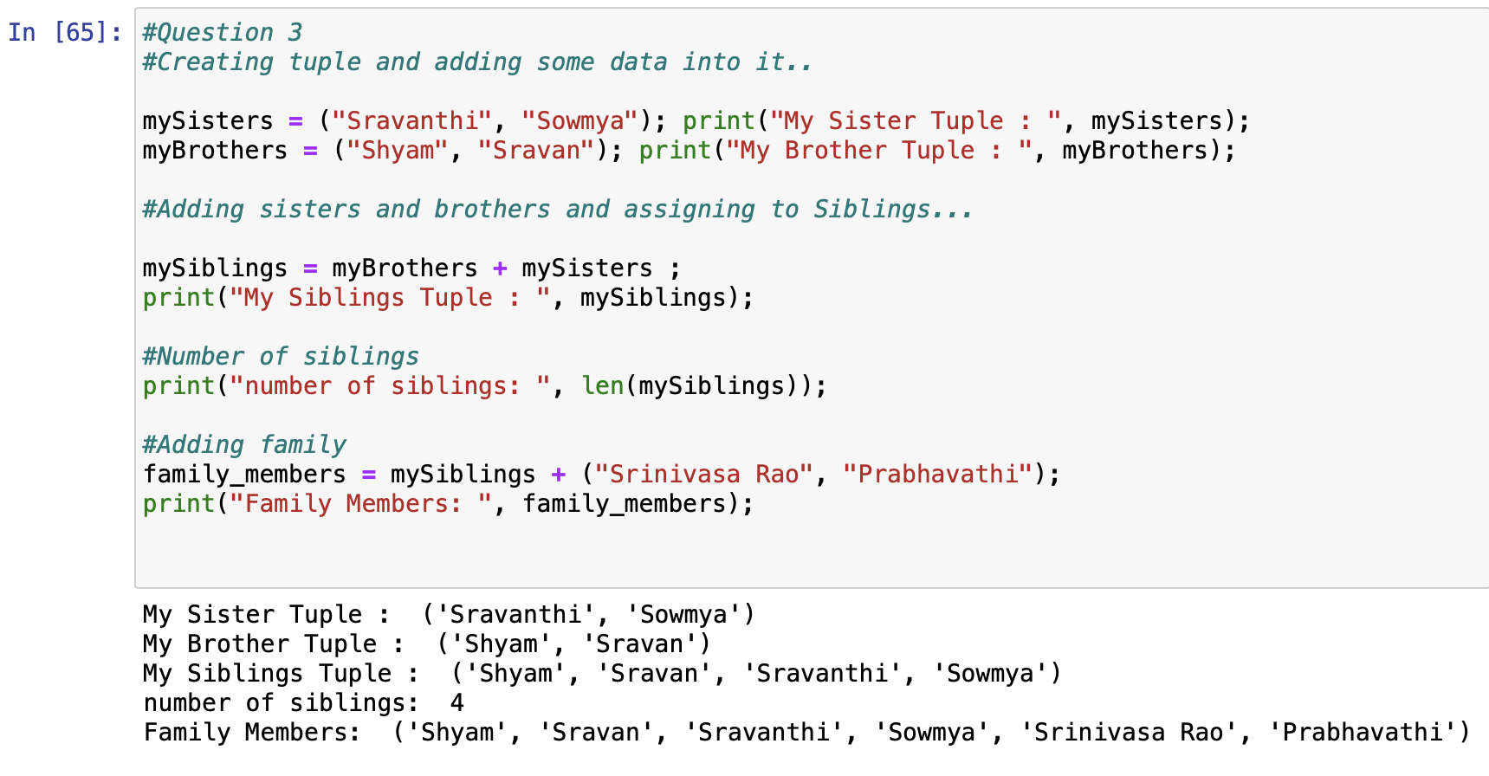

* **Question 4: Find the length of the set it_companies? Add 'Twitter' to it_companies? Insert multiple IT companies at once to the set it_companies? Remove one of the companies from the set it_companies? What is the difference between remove and discard? Join A and B? Find A intersection B? Is A subset of B? Are A and B disjoint sets? Join A with B and B with A? What is the symmetric difference between A and B? Delete the sets completely? Convert the ages to a set and compare the length of the list and the set?**

To get the length of given set I used **len()** function. To add twitter to the set as it is a single value I used **add()** method. And to insert multiple values at a time to the set I used **update()** function. Now to remove one element I removed using **remove()** function. **discard()** method will not throw error when an item is not present where as **remove()** method will throw the error when item is not present in list. To join A and B sets I performed **union()** function and then toto perform intersection of A and B I used **intersection()** function. To find subset I used **subset()** function it returns true if it is subset of other else false, and if no elements are in common, then it is a disjoint and for that I used **disjoint()** method. To get the symmetric difference I used **symmetric_difference()** method which will return all the extra elements present. To clear all the elements in the sets I used **clear()** function.

Now to convert a list into set I used **set()** method and passed list inside that, which is converted to set.

To get and compare lengths I used **len**() method.

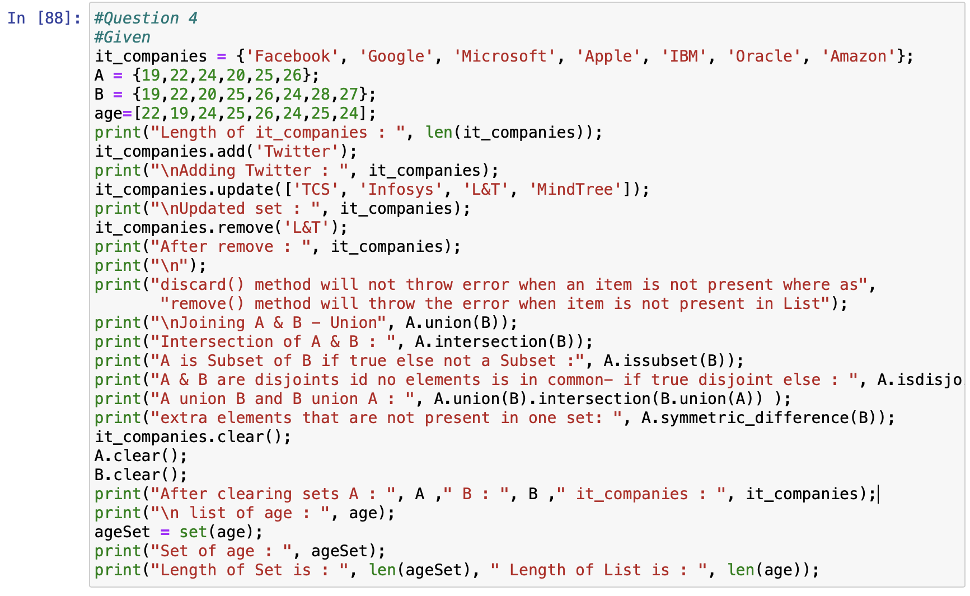

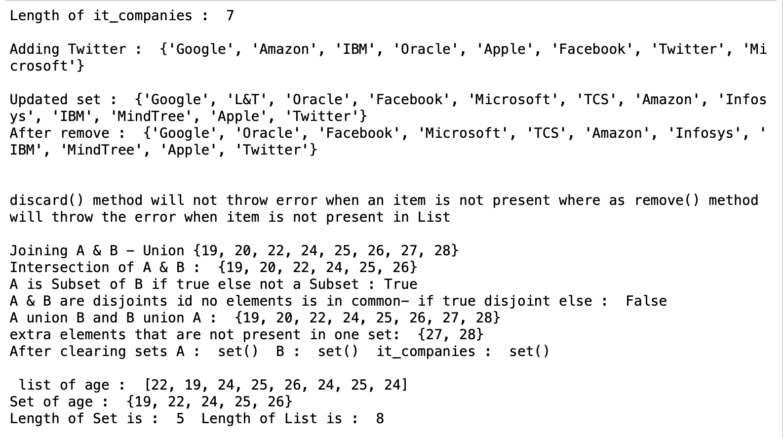

* **Question 5 : The radius of a circle is 30 meters. Calculate the area of a circle and assign the value to a variable name of _area_of_circle_ ? Calculate the circumference of a circle and assign the value to a variable name of circum_of_circle_? Take radius as user input and calculate the area?**

In this program I imported math library to use the pie value. And to calculate area of circle used pi * radius **2. And then to calculate circumference of a circle I used 2 * pi * radius of circle.

To take the radius as input from user I used (float(input()) as it may be a decimal value used float for the radius.

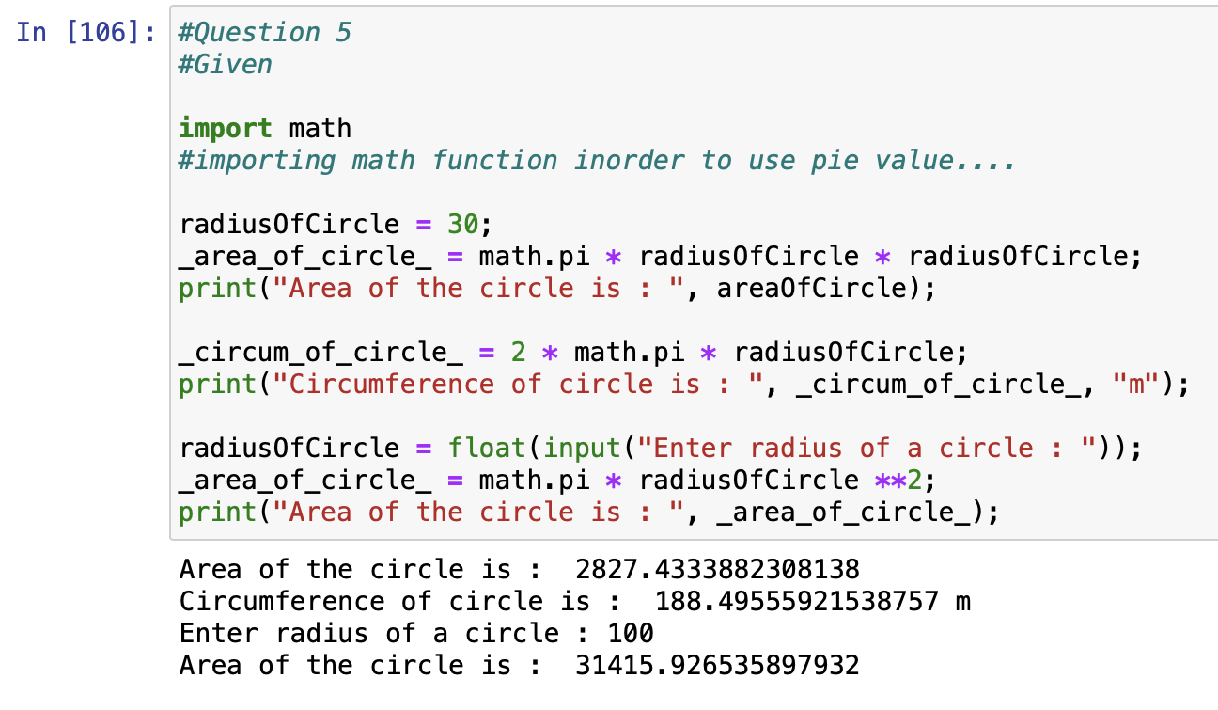

* **Question 6 : “I am a teacher and I love to inspire and teach people”. How many unique words have been used in the sentence? Use the split methods and set to get the unique words?**

To get separate words from the given sentence I used split() method and after splitting to get the unique words I used set to store them as set allow all the unique items.

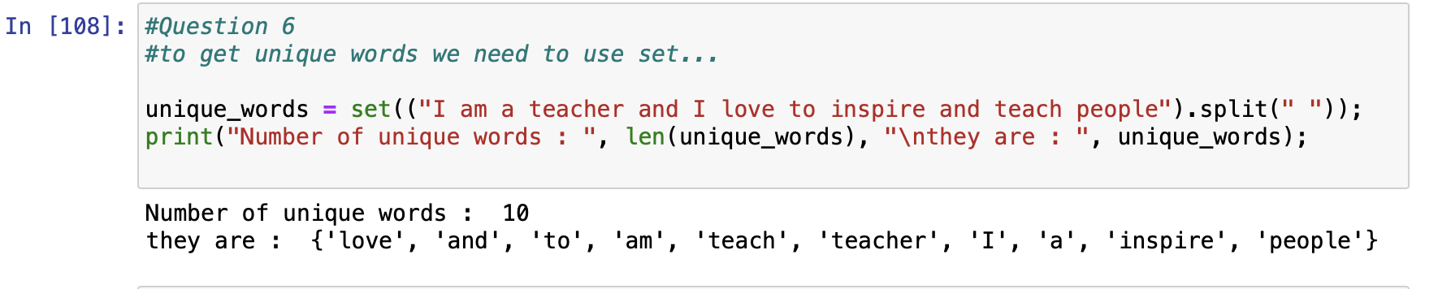

**Question 7 : Use a tab escape sequence to get the following lines.**

**Name Age Country City**

**Asabeneh 250 Finland Helsinki**

I used \t to get the tab space before the words - sentence = "Name \t age \t country city \n Asabeneh 250 \t Finland Helsinki ";

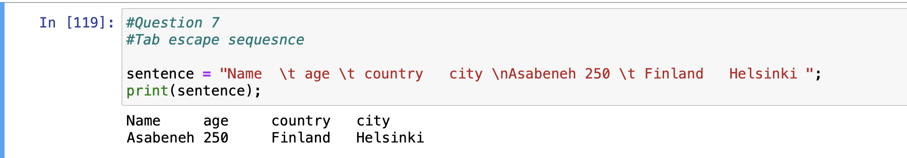

**Question 8: Use the string formatting method to display the following: radius = 10 area = 3.14 * radius ** 2 . “The area of a circle with radius 10 is 314 meters square.”**

To get the area I used 3.14*radius**2 and to get 0 decimal points I used %.0f as by using f we can format the data.

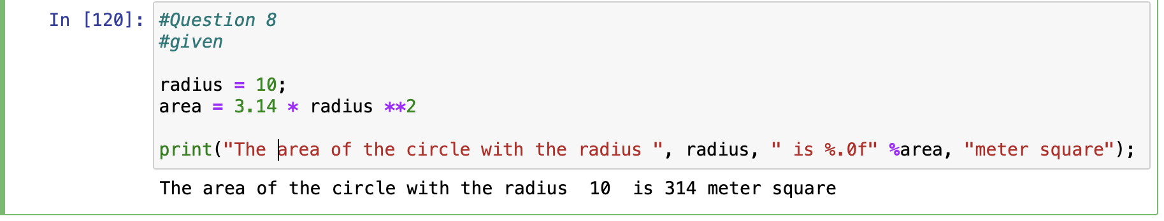

**Question 9 : Write a program, which reads weights (lbs.) of N students into a list and convert these weights to kilograms in a separate list using Loop. N: No of students (Read input from user)**

To read weights of N students I took int(input()) to take number of students and then iterating over a loop by giving the range and inside the loop I took every single weight and converted to kgs from lbs. by multiplying the lbs. weight with 0.453592.

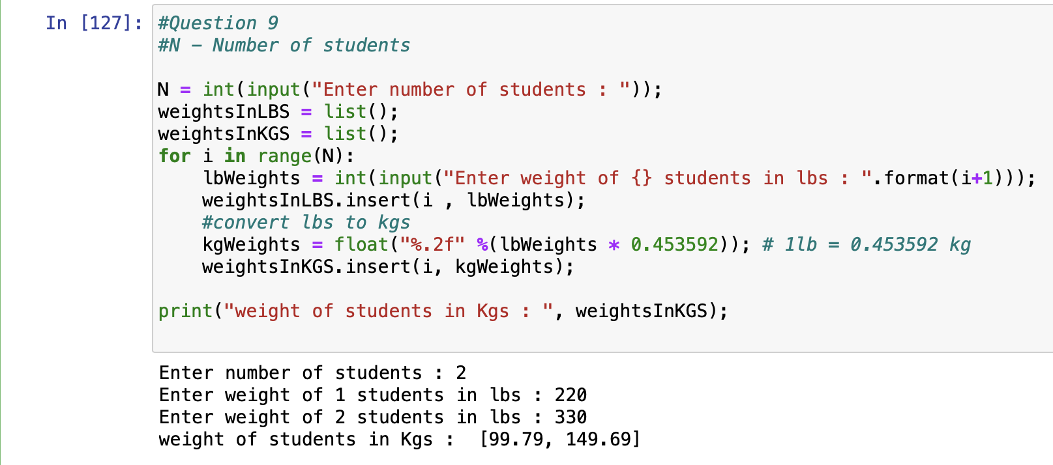

**Question 10 : The diagram below shows a dataset with 2 classes and 8 data points, each with only one feature value, labeled f. Note that there are two data points with the same feature value of 6. These are shown as two x’s one above the other.**

**1) Divide this data equally into two parts. Use first part as training and second part as testing. Using KNN classifier, for K=3, what would be the predicted outputs for the test samples? Show how you arrived at your answer. 2)Compute the confusion matrix for this and calculate accuracy, sensitivity and specificity values.**

In this program I took data points for x like

x = numpy. array([[1,0],[2,0],[3,0],[6,0],[6,0],[7,0],[10,0],[11,0]]); and

y =numpy.array([0,0,1,1,1,0,0,0)];

Then splitting the train and test data using split

x_train, x_test, y_train,y_test = train_test_split(x,y, test_size =0.6, random_state=0, shuffle = False)

//getting library errors while importing.. Trying to resolve..